Single container pod

vi singlecon.yml

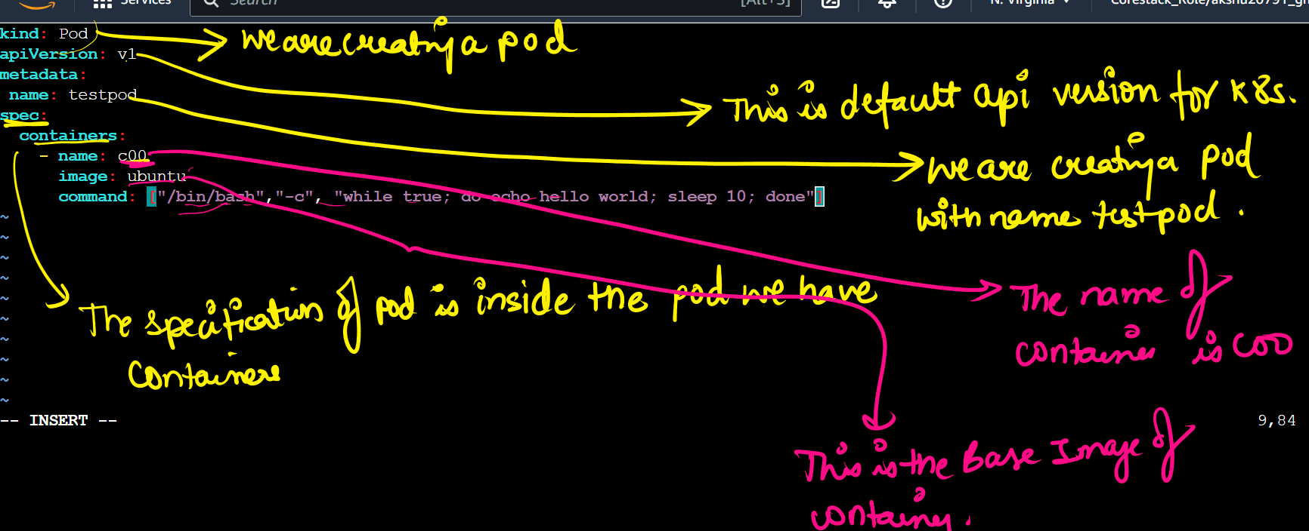

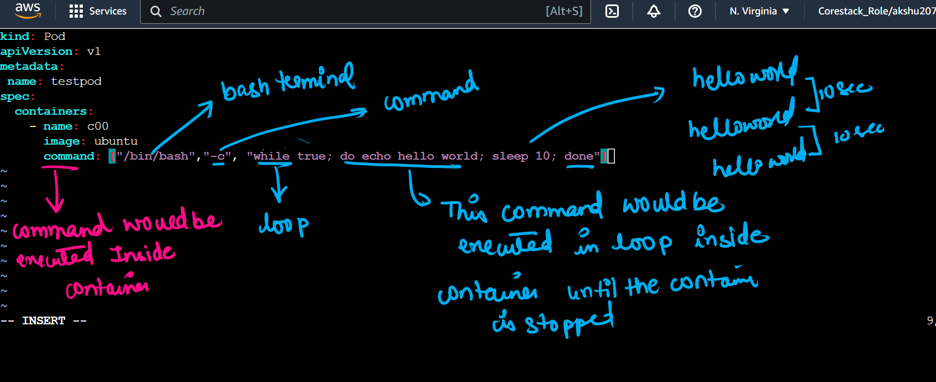

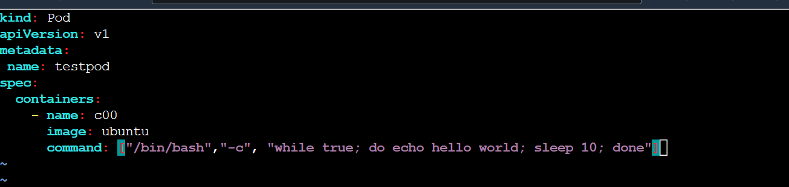

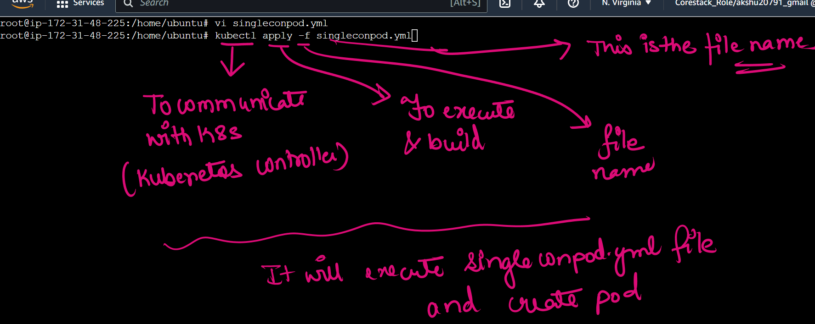

## list the pods

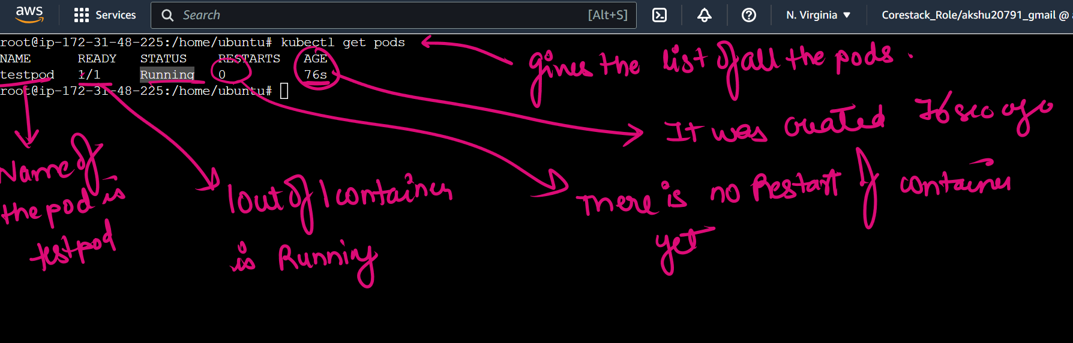

## to find in which node the pod is created

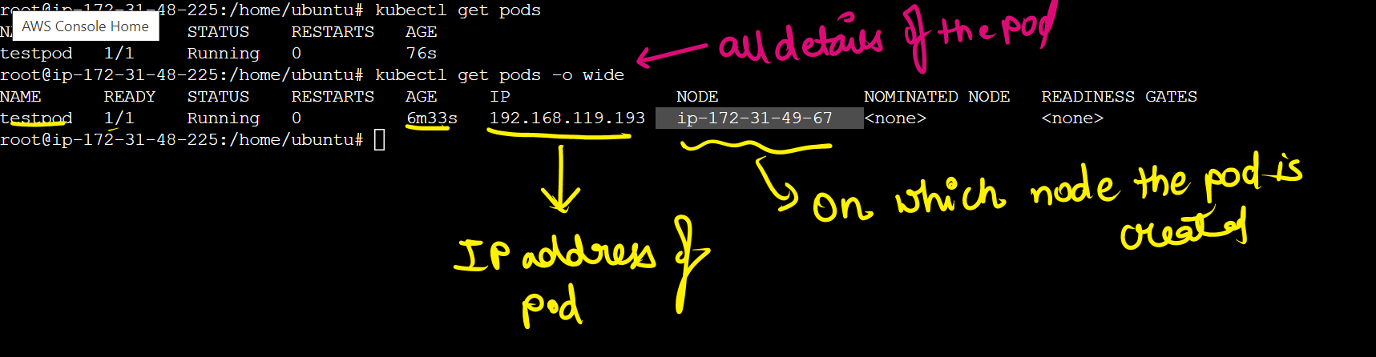

## to see what is running inside the container

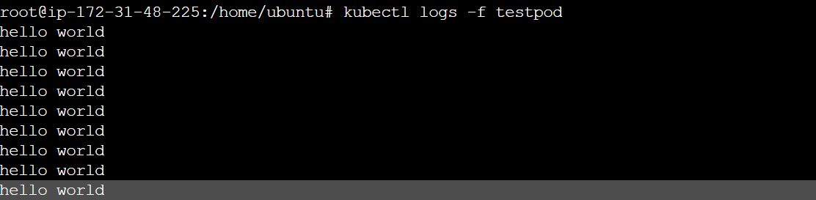

Press ctrl c to come out